The Ultimate Abacus
  - A Complete Physical Number Representation System
A nine bead approach to exploring decimal place value and arithmetic
A. Amalanathan
Master Document • Integrated review edition • 5 October 2026

An invitation to understand
What does a bead represent? Why does its value change from one rod to another? How can the same ten symbols describe a small fraction and a large whole number? These questions guide this document.
The Ultimate Abacus is a physical teaching design for exploring positional notation. It brings whole and fractional places, positive and negative values, and arithmetic into a shared framework. Its central idea is simple: bead count tells us how many; rod position tells us the value of each bead.
“Complete” describes the intended coverage of these representation principles. Every physical frame has a finite range and precision. The title does not imply that every real number can be represented exactly, that every mathematical topic is covered, or that educational superiority has been established.

Contents
Section | What the reader will explore
0 Purpose | Audience, scope and learning approach
1 Number and language | Quantity, symbols, digits and meaning
2 The basis of a number system | Base, grouping and positional notation
3 The decimal number system | Whole places, decimal fractions, zero and sign
4 Operations on numbers | The meaning of the four operations
5 The Ultimate Abacus tool | Frame, bead counts, reading and movement
6 How to use the tool | Worked arithmetic and checking methods
7 Features applications and limitations | Design features, possible uses and evidence limits
Glossary | Terms used throughout the document

How to read this document
Read Sections 0–5 first if the design is new to you. Section 6 then connects the mathematics to actions on the tool. Section 7 separates observable design features from applications that require further development or evaluation.
Teachers and parents can pause at each “Think about it” question. Let the learner predict, explain and check before giving the next step. The aim is to make the reason for a procedure visible.
Figures are labelled as conceptual diagrams or prototype photographs. A conceptual diagram explains a mathematical relationship; it is not a construction drawing.

0 Purpose
This document explains how the decimal number system works and how its principles are expressed in The Ultimate Abacus. It is intended for teachers, tutors, parents and other interested readers who want to understand and use the design.
The design uses nine movable beads for each decimal digit position. A count of no active beads represents zero. Counts from one to nine represent the other digit values. A neighbouring rod represents a place ten times larger or ten times smaller, depending on direction.
The proposed full layout includes positive and negative counting areas and both whole and fractional places. These areas allow the sign and place value of a number to be discussed together. The prototype photograph included later shows the positive portion of a physical tool; it does not demonstrate every part of the proposed full layout.

Learning through questions
A learner should be encouraged to ask what a representation means, why an exchange preserves value, where a digit belongs, when regrouping is needed and how an answer can be checked. Teachers may ask who would use the number and in what situation. Questions should arise naturally from the task rather than become another list to memorise.
The worked examples show correct arithmetic and explain its place value. They are teaching illustrations, not evidence of improved attainment, speed, memory or accessibility. Those outcomes would need independent evaluation.

Think about it
If seven beads represent seven on one rod, could seven beads on another rod represent seventy? What would you need to know before reading them?

1 Number and language
A number expresses a quantity or mathematical value. Language helps us describe that value, discuss relationships and explain our reasoning. Written symbols allow us to record numbers and communicate them without placing every object in front of the reader.
A quantity, its spoken name, its written numeral and a bead arrangement are different representations of the same value. For example, five objects, the word “five”, the numeral 5 and five active unit beads can all represent five.

From symbols to digits
A symbol is a written mark with an agreed meaning. In decimal notation, the symbols 0, 1, 2, 3, 4, 5, 6, 7, 8 and 9 are used as digits. A digit occupies a position in a numeral. Its contribution to the number depends on that position.
Representation | What it tells us
5 | Five units when written as a whole numeral
50 | Five tens and zero units
0.5 | Five tenths and zero whole units
The digit 5 retains its digit value of five, but it contributes 5, 50 or 0.5 in these examples. The position supplies the place value. A bead works in the same way: one bead represents one unit of its rod’s place, which may be a unit, a ten or a tenth.

Think about it
What remains the same in 5, 50 and 0.5? What changes? Explain the difference without saying only that a zero or a decimal point has moved.

2 The basis of a number system
A numeral system provides conventions for representing numbers. This document focuses on positional systems with an integer base of at least two. In such a system, a limited set of digit symbols can represent increasingly large numbers by using additional positions.
The base tells us how many units of one place form one unit of the next larger place. In base ten, ten units form one ten. Ten tens form one hundred. In base two, two units form one group of two, and two groups of two form one group of four.
Base | Digit symbols | Place values from right to left
2 | 0, 1 | 1, 2, 4, 8, …
8 | 0 to 7 | 1, 8, 64, 512, …
10 | 0 to 9 | 1, 10, 100, 1000, …
16 | 0 to 9 and A to F | 1, 16, 256, 4096, …
In base b, the digit values run from 0 to b − 1. The next count after the largest single digit is written as 10 in that base: one group of b and zero individual units. Thus 10 in base two has decimal value two, while 10 in base ten has decimal value ten.

Grouping is the key
We do not need a new symbol for every quantity. We reuse digit symbols in positions whose values are related by the base. Repeated counting leads to an exchange when a place reaches the base. Zero records an empty place.
Time and traditional measurements often use changing group sizes, such as sixty seconds per minute and sixty minutes per hour. A week of seven days is a cycle. Such conventions should not all be described as ordinary uniform base numeral systems.

Think about it
Why does a base ten digit stop at nine? What does the written number 10 record that a single digit cannot?

3 The decimal number system
Decimal notation uses ten digit symbols. One place can contain a digit from zero to nine. Ten units of that place are regrouped as one unit of the place immediately to its left.
Hundreds | Tens | Units | Number
0 | 0 | 9 | 9
0 | 1 | 0 | 10
0 | 9 | 9 | 99
1 | 0 | 0 | 100
Moving left through the place labels multiplies the value of one bead by ten at each step. Moving right divides it by ten. This relationship continues through the units place into decimal fractions.
Place | Value of one bead | Power notation
Thousands | 1000 | 10³
Hundreds | 100 | 10²
Tens | 10 | 10¹
Units | 1 | 10⁰
Tenths | 0.1 = 1/10 | 10⁻¹
Hundredths | 0.01 = 1/100 | 10⁻²
Thousandths | 0.001 = 1/1000 | 10⁻³
The superscript is an exponent. For example, 10³ means 10 × 10 × 10. The value of 10⁰ is 1. A negative exponent gives a reciprocal: 10⁻² = 1/(10 × 10).

Think about it
Why is one hundred worth ten tens? Why is one unit worth ten tenths? Try answering both questions using the same grouping idea.

3 Sign count and place value
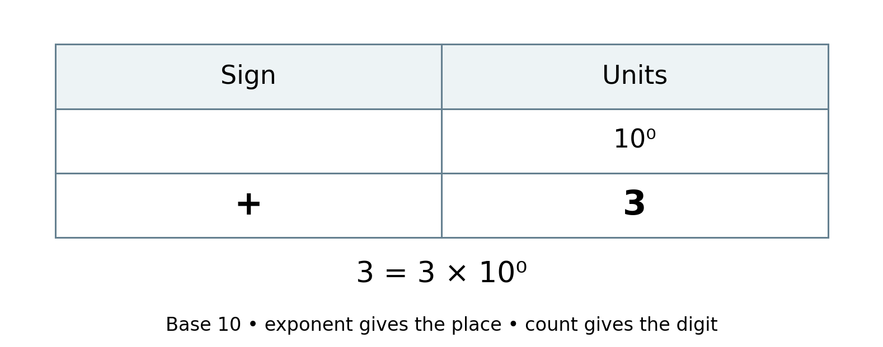
Figure 1. A unit value of 3. Redrawn from original page 11.
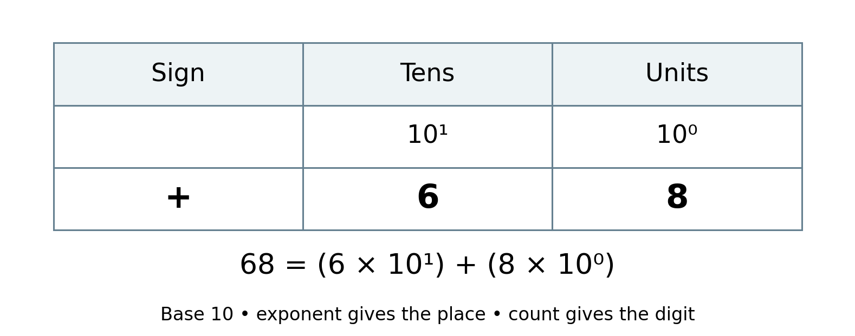
Figure 2. Reading 68 as six tens and eight units. Redrawn from original pages 11–12.
The exponent belongs to the place value. It is not a power applied to the digit itself.

3 Decimal fractions zero and sign
The decimal point separates the units place from the tenths place. Places to the right represent parts of one whole. Each step right makes the value of one bead ten times smaller.
68 = (6 × 10) + (8 × 1)
0.3 = 3 × (1/10)
5.6 = (5 × 1) + (6 × 1/10)
−5.6 = −[(5 × 1) + (6 × 1/10)]
The minus sign in the last expression applies to the entire magnitude 5.6. It must not be applied only to the whole part. The number −5.6 contains a negative whole contribution and a negative fractional contribution.

What zero does
Zero is a number. In positional notation it also acts as a placeholder: the zero in 206 records that there are no tens. Without it, 26 would describe a different value. No active beads on a rod represent a zero digit, but the rod’s place label remains essential.
Zero is neither positive nor negative. A positive number is greater than zero; a negative number is less than zero. The signs + and − can indicate a number’s sign or an operation, depending on context: in 4 − 7 = −3, the first minus denotes subtraction and the second denotes the result’s negative sign.

How much can a frame show
A finite frame represents only a finite range of places. A frame whose smallest place is a thousandth can show 0.125 exactly, but cannot show the infinitely recurring decimal 1/3 exactly. A displayed approximation must be identified as rounded or truncated.

Think about it
Why do 0.5 and 0.50 have the same value? Why do 5 and 50 have different values?

3 Reading signed decimal fractions
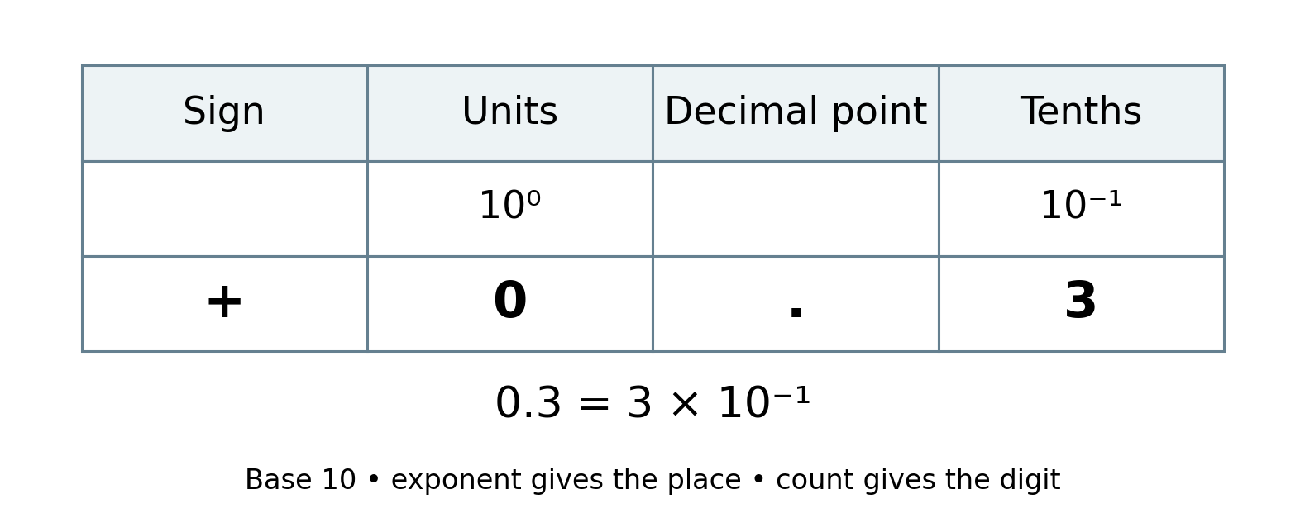
Figure 3. Three tenths. Redrawn from original page 12.
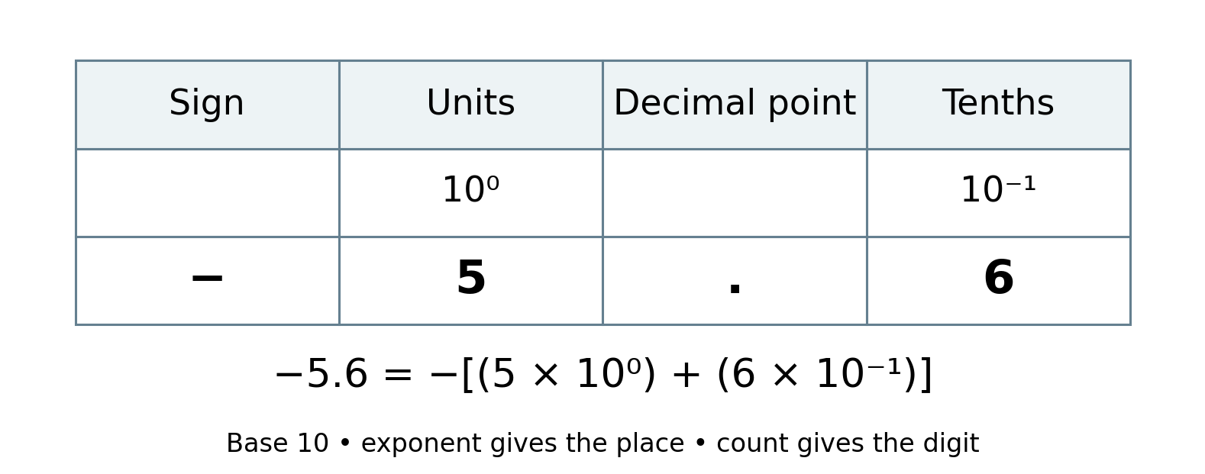
Figure 4. Negative five point six. Redrawn from original pages 12–13 with the sign applied to the entire magnitude.
The decimal point separates units and tenths. The number’s sign applies to both parts together.

3 Four regions of the layout
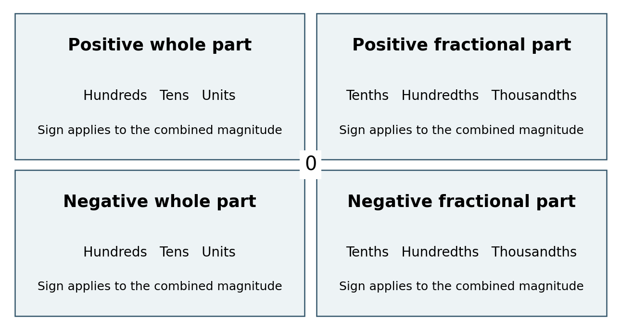
Figure 5. Four sign and place regions. Redrawn from original page 11. The whole and fractional contributions together form one signed number.
The upper regions are used for positive values and the lower regions for negative values. Whole places lie to the left of the decimal boundary and fractional places to its right. The zero line separates the sign areas.
These four regions organise the representation of a single number. They are not the four quadrants of a Cartesian coordinate plane. Rod position represents a place value, not an independent horizontal coordinate.
For an ordinary final reading, use the appropriate sign area consistently across the whole and fractional parts. Read the magnitude from the rod counts and apply one sign to the complete number. For example, five negative units and six negative tenths represent −5.6.
If opposing sign contributions are used temporarily during a demonstration, explain the contributions and simplify them before presenting the final reading. A mixture of positive and negative bead counts must not be read as an ordinary unsigned string of digits.

Think about it
Where would −0.3 be represented? Why does having zero whole units not make its fractional part positive?

4 Operations on numbers
The four familiar arithmetic operations describe different relationships between numbers. They can be introduced through actions on quantities, then extended through place value and mathematical rules.
Operation | Meaning and introductory example
Addition | Combine or increase quantities: 7 + 5 = 12.
Subtraction | Find a difference or remove a quantity: 12 − 7 = 5.
Multiplication | Scale a quantity; whole number multiplication can show equal groups: 5 × 3 = 15.
Division | Find equal shares or the number of equal groups: 15 ÷ 3 = 5.

Connections between operations
Addition and subtraction are inverse operations. Multiplication and division are inverse operations when the divisor is not zero. These relationships help check answers.
Repeated addition illustrates multiplication by a nonnegative whole number: three groups of five give 5 + 5 + 5 = 15. Multiplication by a decimal fraction also involves scaling, so repeated whole groups alone do not explain every multiplication.
Repeated subtraction can illustrate how many equal groups fit into a nonnegative quantity. Division also includes equal sharing, fractions and decimal results. It is not fully described as “taking away one at a time”.
Division by zero is undefined in ordinary arithmetic. Zero divided by a nonzero number is zero. These rules must be preserved in any procedure using the tool.

Think about it
If 3 × 5 = 15, what two divisions can you use to check it? If 7 + 5 = 12, how can subtraction reveal whether the addition was correct?

4 Counting and operation relationships
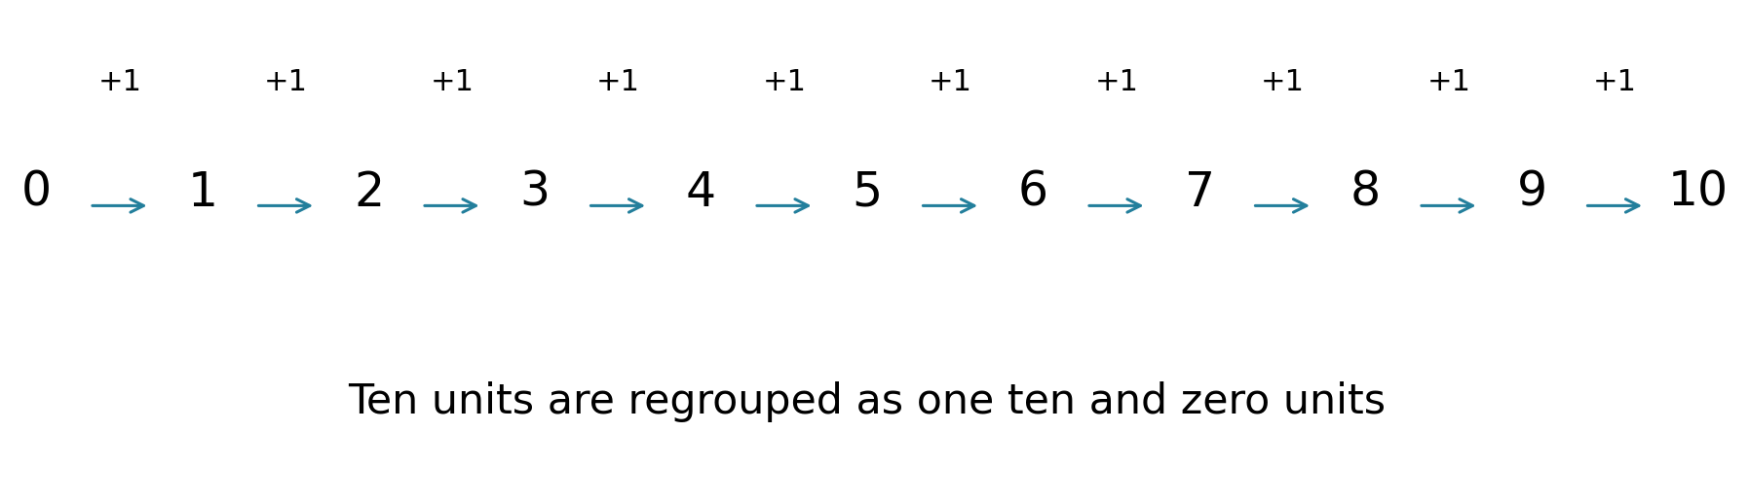
Figure 6. Adding one through the transition from 9 to 10. Redrawn from original page 14.
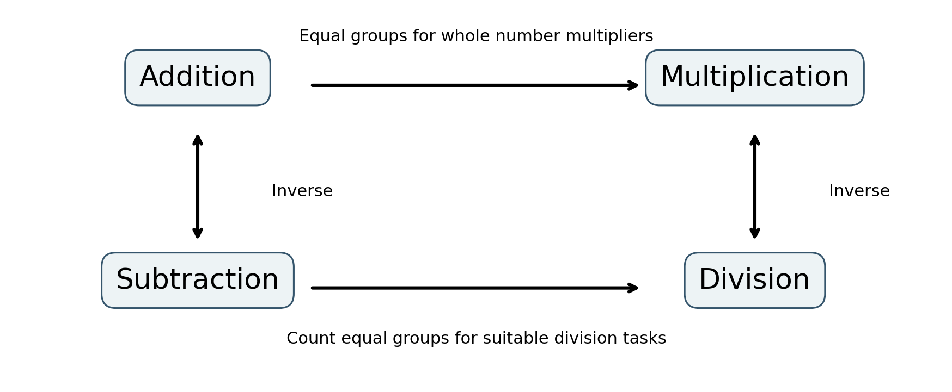
Figure 7. Connections between the operations. Redrawn from original page 16 with the scope of repeated operations made explicit.
For example, 10 ÷ 2 counts five equal groups: 10 → 8 → 6 → 4 → 2 → 0. Repeated grouping introduces the operations; it does not replace their more general meanings.

5 The Ultimate Abacus tool
The design translates a digit into an active bead count and a place into a labelled rod. A decimal digit position uses nine movable beads. The printed scale includes zero to nine, giving ten possible digit readings without needing a bead for zero.
The full conceptual layout provides positive and negative counting areas, with bead storage outside the respective counting areas. Separate sign areas must have sufficient bead provision to support their intended use. The positive prototype photograph shows only its visible positive arrangement.
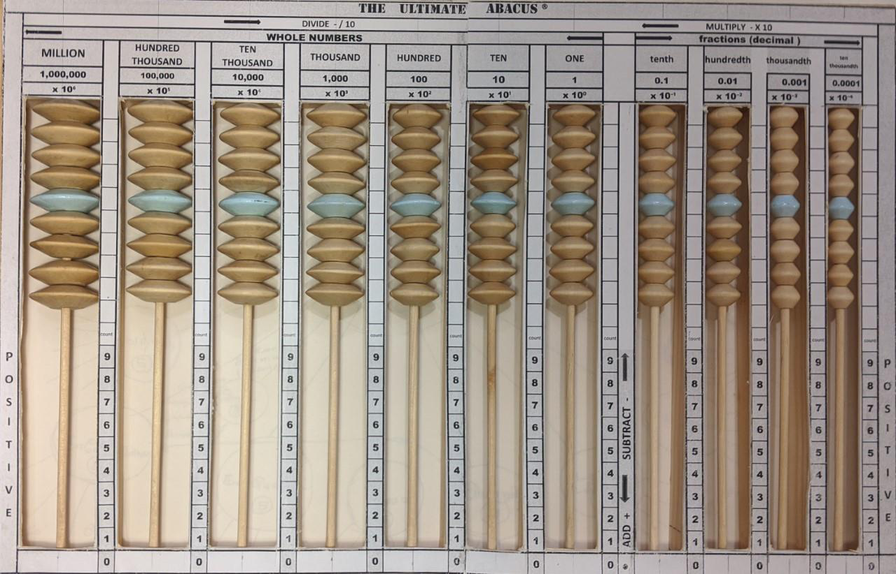
Figure 8. Physical prototype photograph reproduced from page 24 of the original document. The visible arrangement shows positive whole and fractional places.
The beads vary in diameter as a visual and tactile indication of place value. Their thickness is intended to remain consistent. The size differences are cues, not a proportional model: a bead on a hundreds rod is not one hundred times the size of a unit bead.
The fifth bead is distinguished by colour. This provides a reference within a group of nine; it does not give that bead a separate value of five. Each bead on a rod has the same place value.

Think about it
If the fifth bead is coloured differently, does moving that bead alone add five? Explain why its value still depends on its rod.

5 Reading and movement conventions
Begin by identifying the units rod, decimal boundary and counting area. Return beads to their storage positions to clear the display. Count the active beads on each rod and read them in place order. Include zero digits for empty places between occupied rods.
On the original positive scale, active beads form a block against the zero end of the counting area. The bead at the far end of that active block aligns with the digit reading. Beads remaining in storage do not contribute to the displayed count.
Area | Move into the count area | Return to storage
Positive area with storage above | Down: increases positive magnitude | Up: decreases positive magnitude
Negative area with storage below | Up: increases negative magnitude | Down: decreases negative magnitude
Increasing negative magnitude makes the numerical value smaller. For example, activating another negative unit changes −3 to −4; adding positive one to −3 changes it to −2 and removes one negative unit. This distinction prevents the word “add” from being confused with the physical act of adding a bead.

Shifting places
Recreating the same digit pattern one place to the left multiplies the number by ten; one place to the right divides it by ten. The beads themselves slide vertically on fixed rods. A horizontal shift means transferring or re-entering counts on neighbouring rods, not sliding beads sideways through the frame.
A shift is exact only if the required destination places exist. A value must not silently disappear beyond an end of the frame.

Think about it
How can an upward movement mean different numerical changes in the two sign areas? State the sign and the starting value before describing the motion.

5 Frame details and the complete scale
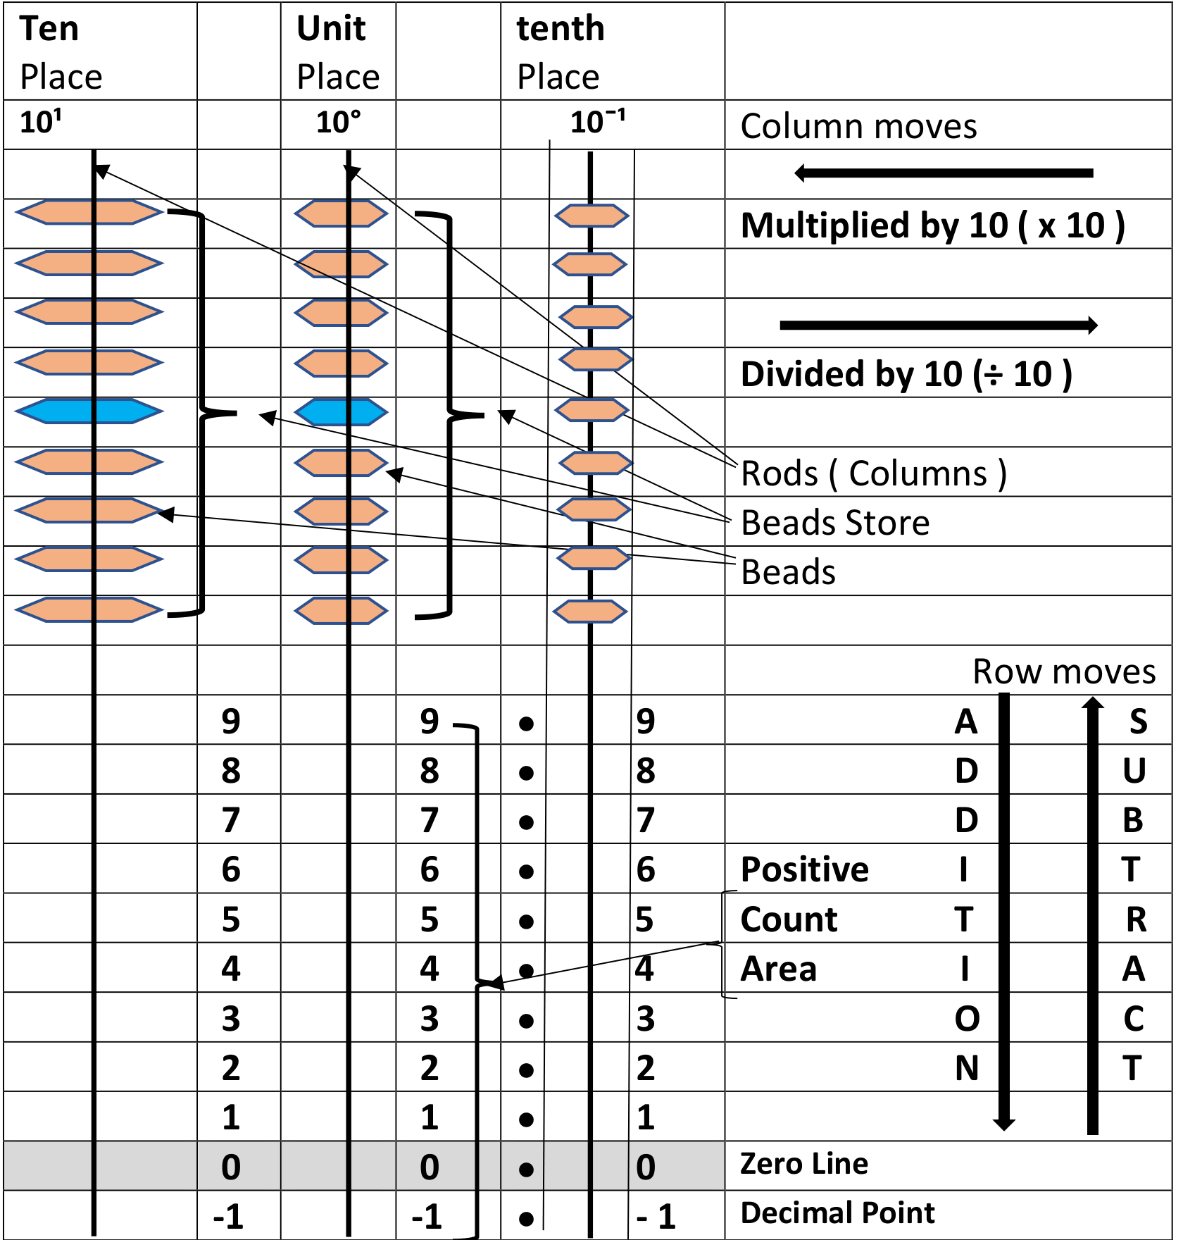
Figure 9. Original frame detail from page 18, including the rods, beads, bead store, counting area, zero line, decimal-point markers and movement directions.
The original diagram distinguishes the rods, individual beads and bead store from the counting area. Its vertical series of dots identifies the decimal boundary between units and tenths; the zero line identifies an empty count. The horizontal arrows describe place changes, achieved by re-entering counts on neighbouring rods. A bead remains on its own rod.

5 Complete signed counting layout
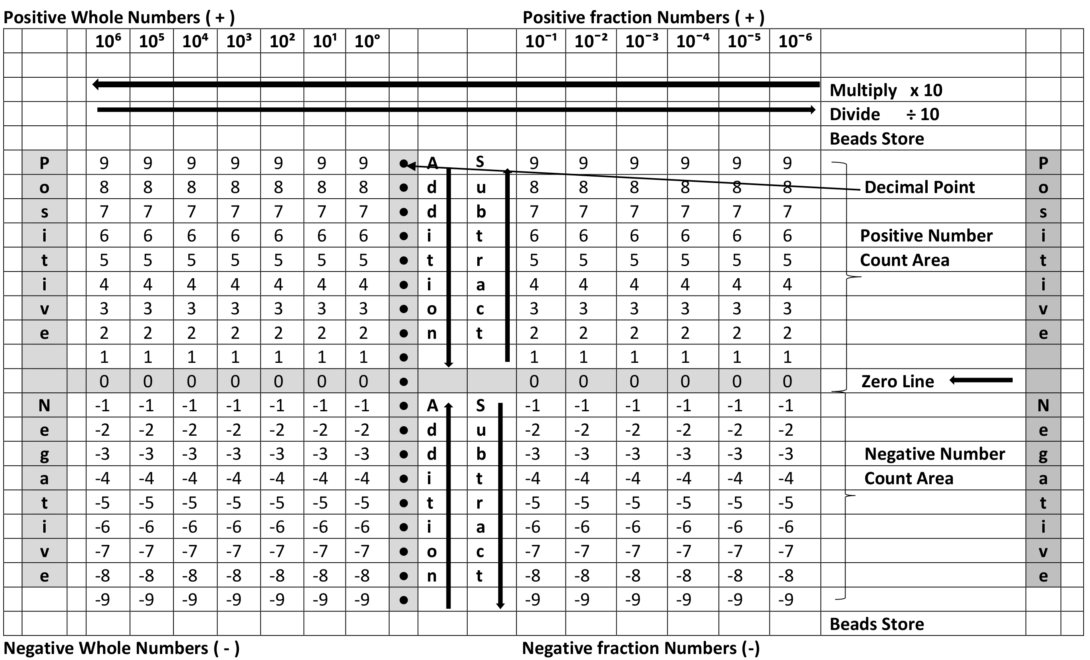
Figure 10. Original complete tool layout from page 19, showing all four regions, bead stores, zero line, decimal-point column and place-change directions.
The four regions organise one signed number, not a Cartesian coordinate pair. The dot column marks the decimal boundary; it is separate from the horizontal zero line. In the original arrows, “Add” and “Subtract” refer to activating and returning beads. In the negative area, adding a negative bead increases negative magnitude and makes the value more negative; it does not add a positive value.

5 Positive whole number rods
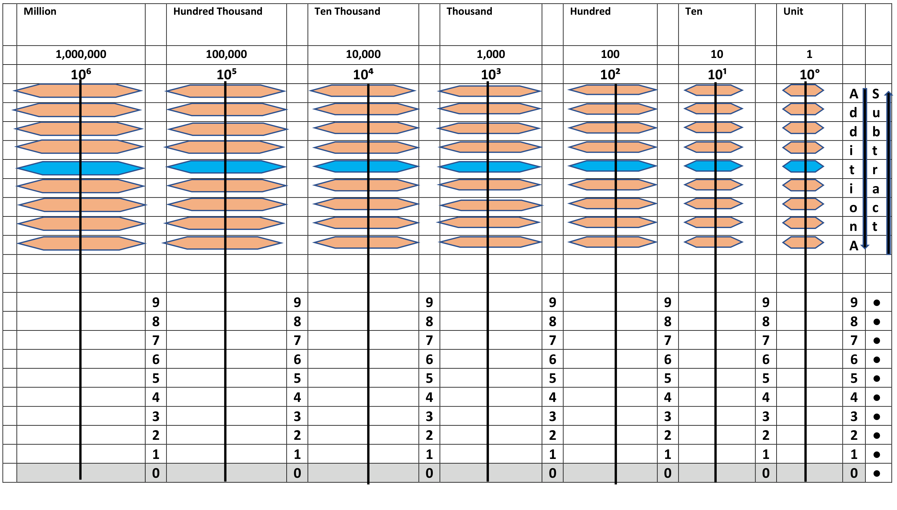
Figure 11. Original positive whole number layout from page 20, with bead store, rods, count scale, decimal-point markers and movement arrows.
Beads are shown in storage, so each digit initially reads zero. Whole place values increase tenfold towards the left. Diameter differences retain the original visual cue and are not proportional to numerical value.

5 Negative whole number rods
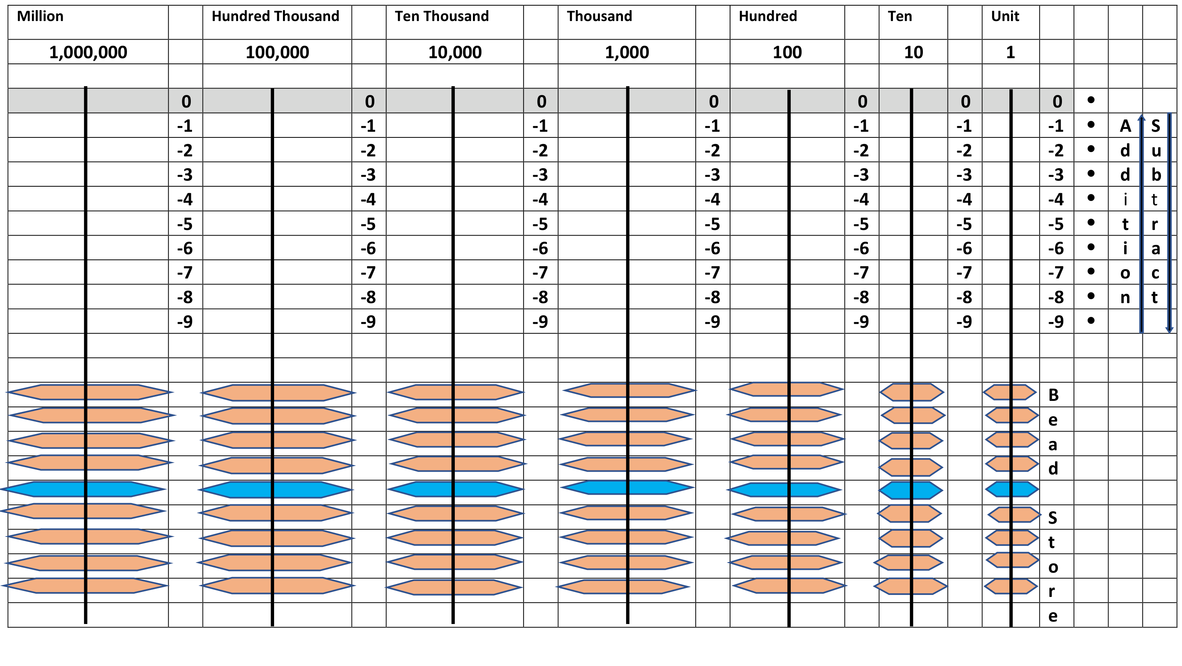
Figure 12. Original negative whole number layout from page 21, preserving the lower bead store, rods, signed count scale and movement arrows.
The original lower bead store and arrows are retained. “Add” here means activate negative beads by moving them upward into the count area. “Subtract” means return negative beads downward to storage. These physical actions increase and decrease negative magnitude respectively.

5 Positive fractional rods
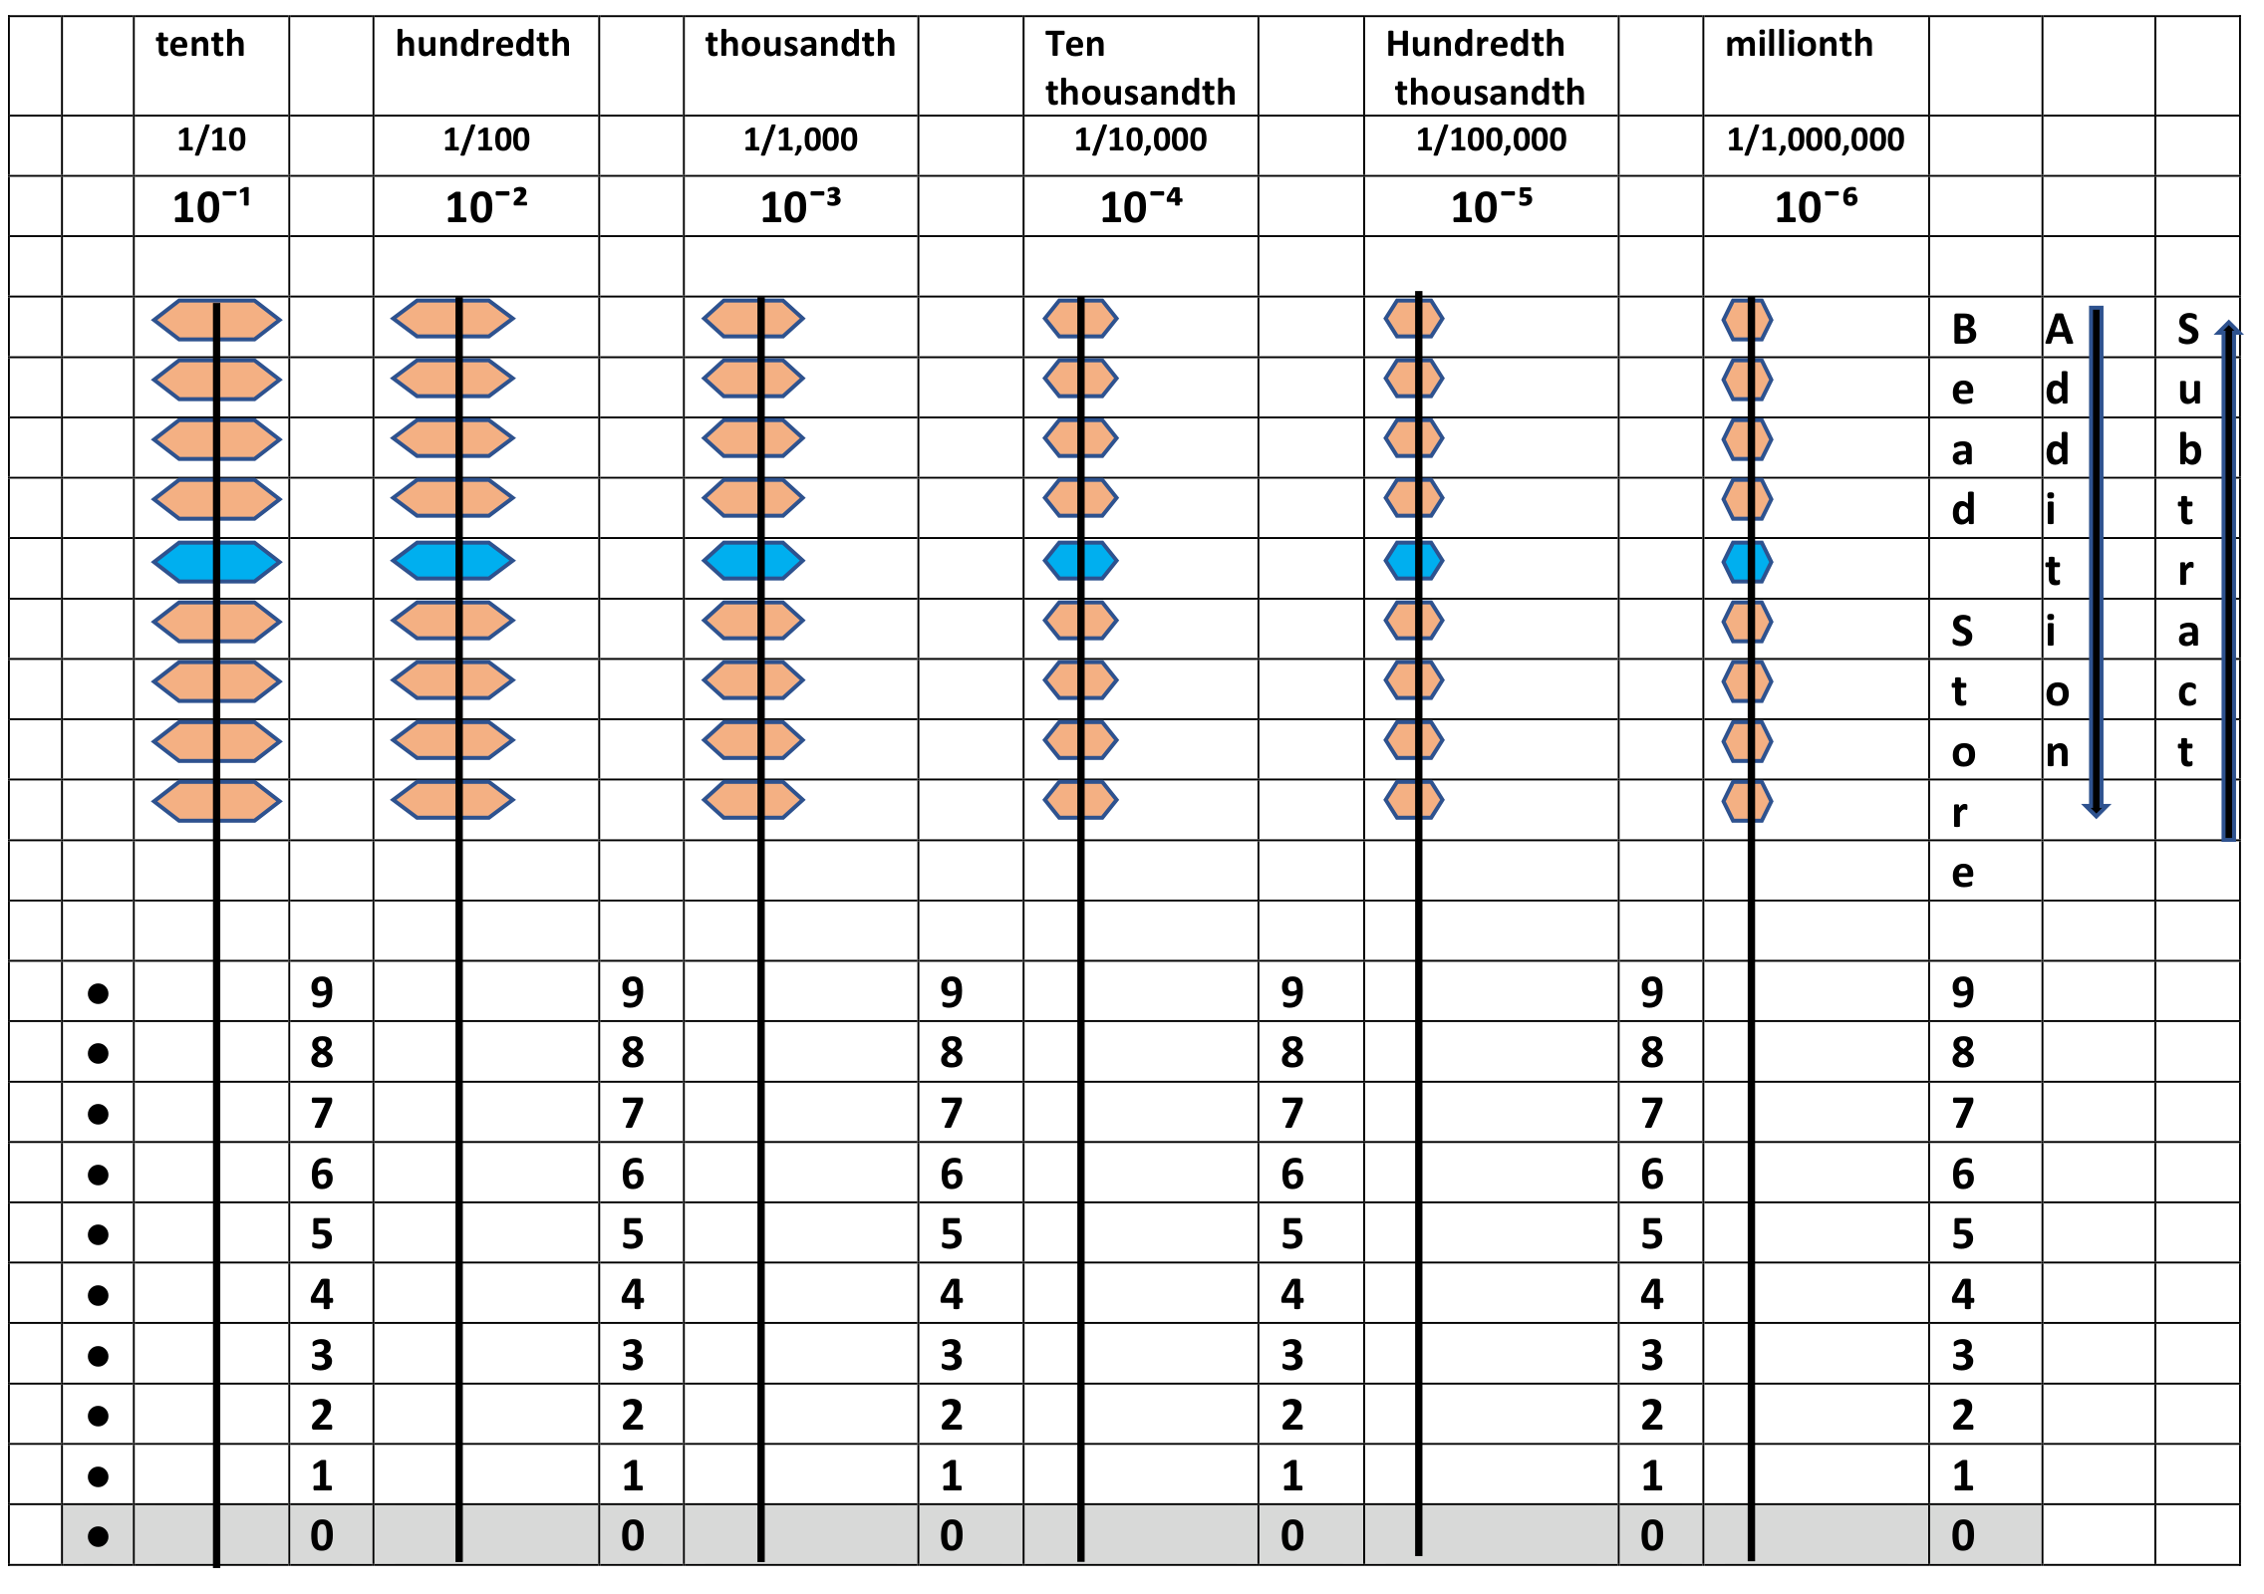
Figure 13. Original positive fractional layout from page 22, preserving the decimal-point markers, fractional places, bead store and movement arrows.
The dot column at the left marks the decimal boundary before the tenths place. The original storage labels, rod scales and arrows are retained. Each successive place to the right is one tenth of the preceding place. The fifth fractional column represents hundred thousandths, 1/100,000; this is the meaning of its original printed label.

5 Negative fractional rods
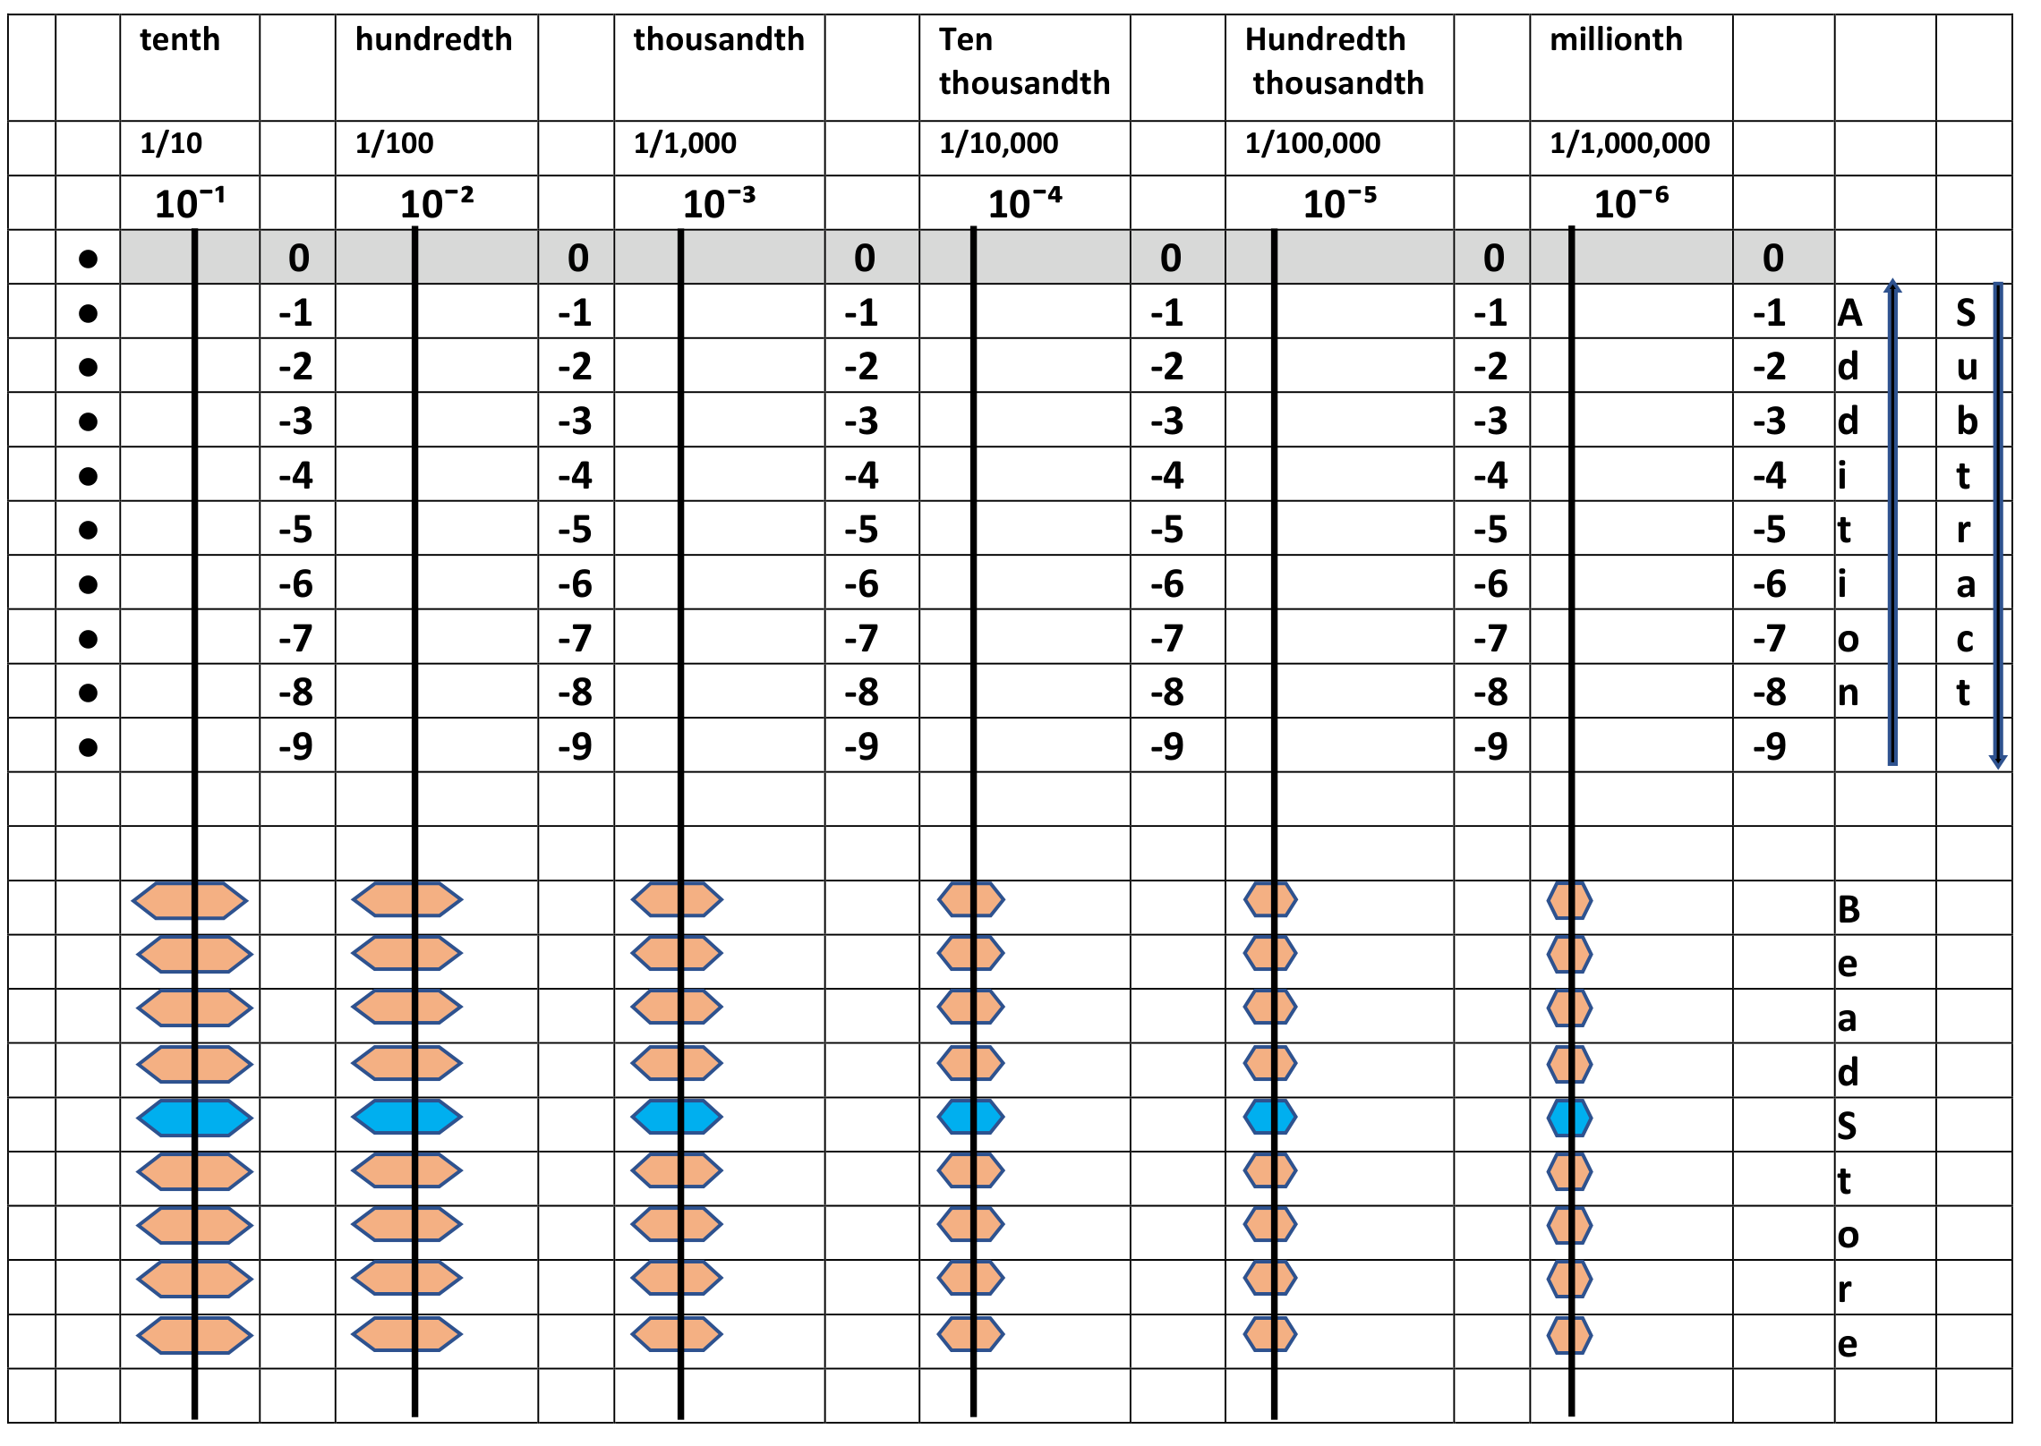
Figure 14. Original negative fractional layout from page 23, preserving the decimal-point markers, fractional places, bead store and movement arrows.
The dot column marks the decimal boundary before the tenths place. Read the active counts as fractional magnitudes with a negative sign. The original upward “Add” arrow activates negative beads; the downward “Subtract” arrow returns them to the lower store. The fifth fractional column means hundred thousandths. Apply one negative sign to any combined whole and fractional magnitude, as in −5.6.

6 How to use the tool

Prepare predict represent and check
Identify the numbers, operation, sign and required places. Predict a reasonable size for the answer. Set or clear the appropriate area, perform the operation and read the result. Check by an inverse operation or a separate calculation. Keep the input numbers visible on paper if the tool is being used as a result accumulator.

Addition within a place
For 0 + 7, activate seven unit beads. For 0.5 + 0.3, activate five tenths and then three more tenths. The result is eight tenths, or 0.8. No regrouping is needed.

Addition with regrouping
For 7 + 5, the units rod has only two unused beads. In value, adding five creates twelve units: one ten and two units. A rod with nine beads cannot display ten units temporarily, so use the complement exchange below.
The ten’s complement gives an equivalent procedure: add one ten and remove five units, because 5 = 10 − 5. Starting from 7, this gives 7 + 10 − 5 = 12. The exchange preserves the total value.
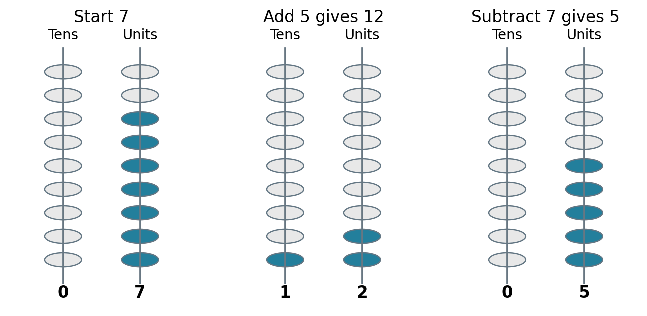
Figure 15. Conceptual active bead counts for 7, 12 and 5. Blue indicates an active count; grey indicates unused beads. This is a state diagram, not the prototype scale or a movement drawing.

Think about it
Why does adding ten and removing five have the same effect as adding five? Explain the value change before moving the beads.

6 Addition across several places
Align corresponding places before adding. Work from the smallest occupied place towards the larger places. At each place include any carried unit from the place to the right.
Step in 999 + 5 | Display after the step
Start | 999
Add one to reach the next ten | 1000
Add the remaining four | 1004
A carry can pass through several rods already showing nine. In 999 + 1, the units become zero and one ten is carried; the tens then become zero and one hundred is carried; the hundreds become zero and one thousand is carried. The result needs a thousands rod.

Decimal example
Place in 6.36 + 4.75 | Calculation | Result digit
Hundredths | 6 + 5 = 11 | 1 and carry 1 tenth
Tenths | 3 + 7 + 1 = 11 | 1 and carry 1 unit
Units | 6 + 4 + 1 = 11 | 1 and carry 1 ten
Tens | 0 + 0 + 1 = 1 | 1
The result is 11.11. Check: 11.11 − 4.75 = 6.36.

The general digit rule
If the digit total is at most nine, display that count. If it is ten or more, display the total minus ten and add one unit to the next larger place. For two decimal digits and a possible carry, the total is at most nineteen, so one carry is sufficient at that step.

Think about it
Why must a carry from the hundredths place become one tenth rather than one unit? What happens if the frame has no rod for the final carry?

6 Subtraction and exchange
To subtract a digit when enough active beads are available on its rod, return the required number to storage. For 6 − 1, remove one unit bead and read 5.

When the smaller place has too few beads
For 12 − 7, the units rod shows two. Exchange one ten for ten units. With the existing two units there are twelve units in value, from which seven are removed. The answer is five units.
Because a decimal rod has only nine beads, it cannot hold the temporary count twelve. Use the equivalent complement procedure: remove one ten, then add 10 − 7 = 3 units to the existing two. The display changes from 12 to 2 to 5.

Exchange across an empty place
Step in 206 − 9 | Hundreds | Tens | Units
Start | 2 | 0 | 6
Remove one hundred | 1 | 0 | 6
Record nine tens of the exchange | 1 | 9 | 6
Complete the unit adjustment by adding 10 − 9 = 1 | 1 | 9 | 7
The result is 197. The intermediate display 196 is part of the procedure, not a completed subtraction result. The hundred exchanged supplies nine tens and the ten used to cover the unit subtraction. Check: 197 + 9 = 206.
If borrowing passes across several zero rods, find the nearest larger occupied place, decrease it by one and set each intervening zero digit to nine. Then complete the complement adjustment on the target rod.

Think about it
Why do the intervening empty places become nine rather than ten? Which part of the exchanged value is being used at the final rod?

6 Crossing zero and signed arithmetic
When subtracting a larger positive number from a smaller one, the result is negative. Decide the sign by comparing the magnitudes, find the difference and display that difference consistently in the negative area. Do not continue borrowing beyond an entirely empty positive display.

Crossing zero
For 4 − 7, remove four positive units to reach zero. There are three further units to subtract. Represent three negative units in the negative counting area and read −3. In that area, with storage below, activating negative beads means moving them upward.
For −3 + 5, cancel three negative units with three positive units of the addition. Two positive units remain, so display +2. The cleared display marks the passage through zero.

A rule for signs
Situation | What to do
Add numbers with the same sign | Add magnitudes and retain that sign.
Add numbers with opposite signs | Subtract the smaller magnitude from the larger; retain the sign of the larger magnitude.
Subtract a signed number | Add its opposite, then apply the addition rules.
Multiply or divide signed numbers | Use magnitudes; like signs give a positive result and unlike signs a negative result.
Examples: −4 + (−7) = −11; 4 − (−7) = 11; (−5) × 3 = −15; (−12) ÷ (−4) = 3. A zero result has no positive or negative sign.
The rules specify mathematical states. The physical frame must permit the required sign area counts and exchanges. A conceptual crossing of zero should not be described as one uninterrupted bead motion unless the actual mechanism supports it.

Think about it
Why does removing a negative contribution increase a value? How could you check 4 − (−7) = 11 using addition?

6 Multiplication with whole numbers
Use the tool to accumulate partial products. Keep the two input numbers separately visible, clear the result area and add each partial product at its correct place. Small multiplication facts may be recalled or built using equal groups.

One digit multiplier
Partial product in 25 × 5 | Value to add
5 units × 5 | 25
2 tens × 5 | 100
Total | 125
The second line adds one hundred, not ten units. Although the digit calculation 2 × 5 gives 10, the 2 represents tens: 20 × 5 = 100.

Two digit multiplier
Partial product in 359 × 76 | Value
359 × 6 | 2154
359 × 70 | 25130
Sum | 27284
For the first round, add 9 × 6 = 54, 50 × 6 = 300 and 300 × 6 = 1800. For the second round, add 9 × 70 = 630, 50 × 70 = 3500 and 300 × 70 = 21000. Each contribution belongs to the place determined by both factors.
The result is 27,284. An estimate, 360 × 76 = 27,360, is close and supports the scale of the result. The exact inverse check is 27,284 ÷ 76 = 359.

Why it works
Multiplication distributes over addition: (300 + 50 + 9) × (70 + 6) is the sum of all six place value products. Regrouping on the rods records the same total as written multiplication.

Think about it
Why does the second round start one place farther left than the first? Explain it using seventy, rather than saying only “add a zero”.

6 Multiplication with decimal fractions
Decimal multiplication follows the same place value rule. Multiply the digit counts and multiply their place values. For example, six hundredths times four hundredths gives twenty four ten thousandths: 0.06 × 0.04 = 0.0024.

Worked example
16.86 × 5.34
Multiplier part | Partial product
0.04 | 16.86 × 0.04 = 0.6744
0.3 | 16.86 × 0.3 = 5.0580
5 | 16.86 × 5 = 84.3000
Total | 90.0324
Prepare places down to the ten thousandths rod. Add the three partial products in their correctly aligned places. The displayed result is 90.0324.

An equivalent scaling check
16.86 = 1686/100 and 5.34 = 534/100. Therefore the product is (1686 × 534)/10000 = 900324/10000 = 90.0324.
Each factor has two decimal places in its given form, so the integer product is scaled by four decimal places. This is a consequence of dividing by 100 twice, not an arbitrary rule about moving a point. Trailing zero digits can be omitted without changing the result.
A quick estimate gives 17 × 5.3 ≈ 90.1, consistent with an answer near ninety. If the frame lacks four fractional places, the exact product cannot be shown without an additional recording method.

Think about it
Why does multiplying two tenths give a hundredth? If both factors are less than one and positive, should their product be larger or smaller than either factor?

6 Division and a temporary work area
Division needs separate records for the remaining dividend and the quotient being built. Use clearly identified areas or an external record. The original design uses the normally negative counting area for a temporary unsigned quotient record during positive division.

Label before starting
Cover or override the sign interpretation of that area with the label QUOTIENT WORK AREA. While this mode is active, its bead counts are quotient digits, not negative contributions to the remaining dividend. Do not add the two areas together as a signed number.
Check that the frame’s bead arrangement can maintain the required remainder and quotient counts at the same time. If simultaneous use is mechanically unavailable, record the quotient separately on paper. This preserves the procedure without assuming an unverified mechanism.

Simple divisions
Division | Quotient | Remainder | Check
9 ÷ 3 | 3 | 0 | 9 = 3 × 3
12 ÷ 4 | 3 | 0 | 12 = 4 × 3
56 ÷ 11 | 5 | 1 | 56 = 11 × 5 + 1
For 56 ÷ 11, five groups of eleven account for fifty five. Subtract fifty five from the dividend and record five in the quotient units place. The remainder is positive one, written “remainder 1”, not “R − 1”.

The check for whole number division
Dividend = divisor × quotient + remainder. For a nonnegative whole dividend and positive whole divisor, the remainder must be at least zero and less than the divisor.
At the end, read and record the quotient with its intended sign, clear the work area label and restore normal signed reading before the next activity.

Think about it
Why is a quotient stored in a normally negative area not automatically a negative answer? Which label tells you how to interpret that area?

6 Division through place values

Worked example with a remainder
3257 ÷ 6
Step | Value removed | Remaining dividend | Quotient so far
Five hundreds of groups | 6 × 500 = 3000 | 257 | 500
Four tens of groups | 6 × 40 = 240 | 17 | 540
Two unit groups | 6 × 2 = 12 | 5 | 542
The answer is 542 remainder 5. Check: 6 × 542 + 5 = 3257, and 5 is less than the divisor 6. This table shows the full place values rather than treating the leading digits as unlabelled quantities.

Decimal division
36.97 ÷ 5
Quotient contribution | Value removed | Remaining dividend
7 units | 35 | 1.97
3 tenths | 1.5 | 0.47
9 hundredths | 0.45 | 0.02
4 thousandths | 0.02 | 0
The answer is 7.394. The thousandths rod is required even though the original dividend ends at hundredths. Check: 7.394 × 5 = 36.970.
For a decimal divisor, scale both dividend and divisor by the same power of ten before dividing. For example, 3.6 ÷ 0.5 = 36 ÷ 5 = 7.2. Scaling both numbers preserves the quotient.
Some divisions continue indefinitely. For 1 ÷ 3, no finite number of decimal rods gives an exact terminating answer. Decide the required precision and identify a rounded or truncated result.

Think about it
Why is it legitimate to write 36.97 as 36.970? Why does the final step represent four thousandths rather than four hundredths?

7 Features applications and limitations

Features of the design
The decimal digit range is built into a nine bead position. The printed zero position makes an empty count explicit. Rod labels make neighbouring place relationships visible, and whole and fractional places share the same factor of ten. The full layout provides a framework for representing sign as well as magnitude.
A contrasting fifth bead supplies a grouping cue. Different bead diameters give a further indication of place. These are observable design choices. They do not by themselves establish that learners make fewer errors or understand more quickly.

Potential applications
Application | Scope and limitation
Place value teaching | Explore digit counts, zero and equal value exchanges; teaching effectiveness needs evaluation.
Metric overlays | Relabel compatible decimal places for a fixed measurement unit; identify the reference unit and avoid mixing quantities.
Tactile use | Bead size and position may support touch based exploration; tactile labels and user testing are still needed.
Mental arithmetic | Learners may practise imagining familiar displays; transfer and speed are unproven.
Algebra and coordinates | Represent numerical substitutions or separate coordinate values; extra notation is needed. The four regions are not a coordinate plane.
Complement methods | Compare the arithmetic identities with other complement based methods, including methods described as Vedic; overlap does not prove an origin or distinct benefit.

Think about it
Which features can you observe directly? Which proposed benefits would require evidence from learners or teachers?

7 Boundaries and future evaluation

Mathematical and physical boundaries
A finite frame has a maximum magnitude and a smallest place increment. Recurring decimals and irrational numbers cannot generally be represented exactly. Carrying, borrowing and shifting may require places beyond the available frame. An approximation needs an explicit precision rule.
Nine beads constrain a normal decimal digit count, but cannot prevent every error. A learner can still choose the wrong rod, sign, movement or interpretation. Complement methods also require understanding of place value, exchanges and the digit complements. Multiplication and division require further relationships and procedures.
The positive prototype photograph does not verify the full signed mechanism, simultaneous division records, long term durability, or accessibility. Construction and classroom versions should be checked against those intended uses.

Other bases
The representation principle extends to any integer base b ≥ 2. A normal digit position requires b − 1 beads and a zero reading. Neighbouring places are related by b rather than ten. Base two needs one bead per digit position; base eight needs seven; base sixteen needs fifteen and an appropriate symbol scale. Changes to bead provision, labels and spacing are required.

An invitation to independent evaluation
Teachers, learners and interested researchers are invited to examine the design, use it critically and report what works and what remains difficult. Useful questions include whether learners can explain exchanges, read zero places, distinguish sign from movement and transfer their understanding to written notation.
Comparative claims would require a defined teaching method, appropriate comparison, participant information and reliable outcome measures. This document offers a design and mathematically explained examples; it does not present such a study.
The name The Ultimate Abacus is retained as the design’s name. It is not a ranking against other abacus systems or a claim that no refinement is possible.

Glossary
Term | Meaning
Active bead | A bead moved into a designated counting area and included in its reading.
Base | The grouping factor between adjacent places in a positional system.
Digit | A symbol used in one position of a numeral.
Digit value | The count represented by a digit, such as five for 5.
Place value | The value of one unit at a position, such as ten or one tenth.
Magnitude | The size of a number without its sign; the magnitude of −5.6 is 5.6.
Regrouping | Exchanging equal values between places.
Carry | One unit transferred to the next larger place after reaching the base.
Borrow or exchange | Taking one unit of a larger place to supply smaller places.
Ten’s complement | For a digit a from 1 to 9, the value 10 − a.
Multiplicand and multiplier | The quantities being multiplied; both are factors.
Dividend and divisor | The quantity divided and the nonzero quantity by which it is divided.
Quotient | The result of division, or the whole group count in division with a remainder.
Remainder | The amount left after whole groups have been accounted for.
Precision | The smallest place or level of detail retained in a representation.

Source and figure credit
Based on A. Amalanathan, The Ultimate Abacus, An Introduction to Nine Beads Abacus, original 62 page document. Figures 9–14 reproduce the original annotated diagrams from pages 18–23, preserving their frame details. Figure 8 reproduces the physical-tool photograph from page 24. Other figures redraw or explain the visual material from pages 11–14 and 16, with a supplementary active bead-count diagram. Clarifications of original labels appear beneath the relevant figures.

